
_________________________________________________________________________________

MAMC01803 Analytics for Managers
Assignment 2 - Report
_________________________________________________________________________________
Study Block 1 |  |  | 10th February – 11th April, 2025
Date issued
Due date |  |  | 7th April (Monday W9) |  |  | Time |  | Before 9:00 AM
Delivery: |  |  | Submit to Turnitin via Moodle before deadline
Weighting |  |  | 70%
Marks out of |  |  | 30
Instructions |  |  | Complete this cover sheet and attach to you your assignment.  - This assignment must be your own work.  - Collusion, copying or plagiarism may result in disciplinary action.  - We advise that you keep a copy of this assignment.  - Word limit is 3000  Refer to following website for reference related resources:  https://studentservices.op.ac.nz/assets/Uploads/OP-APA-7th-quick-guide-May-2020.pdf
I confirm that:
This is an original assessment and is entirely my own work.
Where ideas, tables, diagrams etc. of other writers have been used, I have acknowledged the source in every case.
This assignment has not been, nor will be, submitted as assessed work for any other academic course.
 | Student’s Name |  |  | ID No |  |  | Signature
 | Gielo Joseph Fernandez |  |  | 737214696 |  |  | Gielo
 | Date | March 24, 2025 |  |  | Cohort Number |  |  |  | 1

Table of Contents
1. Introduction 1
2. IBM Employee Attrition Dataset 1
2.1 Table of categorization of variables into categorical or nominal along with the description of the variables 2
3. Business Problems 4
3.1 Identifying and analysing factors affecting attrition rate in a company 4
3.2 Identifying and Analysing Factors that affect Job Satisfaction in a company 8
3.3 Identifying and Analysing Factors that affect Work Life Balance in a company 9
4. Conclusion 9
5. References 10

1. Introduction
In the HR world, analytics in human resources have been around for years, as far as 1900s, traces of notion of measurement in human resources can be found(Kaufman, 2014, as cited in Marler & and Boudreau, 2017). So what is HR Analytics? According to Collins (as cited in Lalwani, 2025), it is by using statistical methods to integrate HR, talent management, financial, and operational data to create insights on how investments in human capital assets contribute to key business outcomes such as generating revenue, minimizing expenses, mitigating risks, and executing strategic plans.
This report aims to analyse an HR department of a big company in management of workforce, with a focus on handling employee retention, job satisfaction, and work-life balance. Using different types of analytics method, and with the support of relevant and recent articles, this report showcases how HR management can leverage analytics methods to make confident data driven decisions that is supported by data.
This data was selected from Kaggle (Ghate, 2020). This data will be used along with articles journals sourced from the internet to support the different analyses. The limitations of the methods used in the analyses will also be discussed in more detail.
Section 2 discusses the dataset that will be used in this report. Section 3 discusses the three business problems identified, as well as analyses done and recommendation.

2. IBM Employee Attrition Dataset
A dataset is an organized collection of data. The most basic representation of a dataset is data elements presented in tabular form. Each column represents a particular variable. Each row corresponds to a given value of that column’s variable (Pecherskiy, 2016). Each column is categorised into numerical or categorical data. Then it is further categorised into the four levels of measurement: nominal, ordinal, interval and ratio. These levels are used to categorize and describe data based on their characteristics and properties (Stevens, 2023).
This dataset is about the employee attrition of IBM employees which were created by IBM data scientists, which was sourced from Kaggle (Ghate, 2020). The dataset consists of over 23436 rows, and 37 columns.
Regarding data cleaning the following steps were executed. First, rows that contained empty values were removed. Second, rows that had misaligned values or values that contained data from a different column were removed. Third, rows, that contained values ‘Test’ were removed as well. Since we have columns that contained categorical values, we needed to convert them into numerical values so that we can do clustering or prescriptive analytics. After data cleaning, we are left with 10005 rows for data analyses.
For data coding, the table below shows the equivalent numerical value based on the categorical representation.
Variables | Representation
Attrition | 0 = 'Current Employee', 1 = 'Voluntary Resignation'
BusinessTravel | 0 = 'Non-Travel', 1 = 'Travel_Rarely', 2 = 'Travel_Frequently'
Department | 0 = 'Sales', 1 = 'Human Resources', 2 = 'Research & Development'
EducationField | 0 = 'Life Sciences', 1 = 'Human Resources', 2 = 'Marketing', 3 = 'Medical', 4 = 'Technical Degree', 5 = 'Other'
Gender | 0 = 'Male', 1 = 'Female'
JobRole | 0 = 'Healthcare Representative', 1 = 'Human Resources', 2 = 'Laboratory Technician', 3 = 'Manager', 4 = 'Manufacturing Director', 5 = 'Research Director', 6 = 'Research Scientist', 7 = 'Sales Executive', 8 = 'Sales Representative'
MaritalStatus | 0 = 'Single', 1 = 'Divorced', 2 = 'Married'
Over18 | 0 = 'No', 1 = 'Yes'
OverTime | 0 = 'No', 1 = 'Yes'
Employee Source | 0 = 'Adzuna', 1 = 'Company Website', 2 = 'GlassDoor', 3 = 'Indeed', 4 = 'Jora', 5 = 'Linkedin', 6 = 'Recruit.net', 7 = 'Referral', 8 = 'Seek'

2.1 Table of categorization of variables into categorical or nominal along with the description of the variables

Variables | Type of Data | Data Measurement Type
Age | Numerical | Ratio
Attrition | Categorical | Nominal
BusinessTravel | Categorical | Ordinal
DailyRate | Numerical | Ratio
Department | Categorical | Nominal
DistanceFromHome | Numerical | Ratio
Education | Categorical | Ordinal
EducationField | Categorical | Nominal
EmployeeCount | Numerical | Ratio
EmployeeNumber | Categorical | Nominal
Application ID | Categorical | Nominal
EnvironmentSatisfaction | Categorical | Ordinal
Gender | Categorical | Nominal
HourlyRate | Numerical | Ratio
JobInvolvement | Categorical | Ordinal
JobLevel | Categorical | Ordinal
JobRole | Categorical | Nominal
JobSatisfaction | Categorical | Ordinal
MaritalStatus | Categorical | Nominal
MonthlyIncome | Numerical | Ratio
MonthlyRate | Numerical | Ratio
NumCompaniesWorked | Numerical | Ratio
Over18 | Categorical | Nominal
OverTime | Categorical | Nominal
PercentSalaryHike | Numerical | Ratio
PerformanceRating | Categorical | Ordinal
RelationshipSatisfaction | Categorical | Ordinal
StandardHours | Numerical | Ratio
StockOptionLevel | Categorical | Ordinal
TotalWorkingYears | Numerical | Ratio
TrainingTimesLastYear | Numerical | Ratio
WorkLifeBalance | Categorical | Ordinal
YearsAtCompany | Numerical | Ratio
YearsInCurrentRole | Numerical | Ratio
YearsSinceLastPromotion | Numerical | Ratio
YearsWithCurrManager | Numerical | Ratio
Employee Source | Categorical | Nominal

Variables | Description
Age | Age of Employee
Attrition | whether the employee has left the company (Voluntary Resignation) or is still employed (Current employee).
BusinessTravel | frequency of business travel for the employee (e.g., Travel_Rarely, Travel_Frequently, Non-Travel).
DailyRate | daily rate of pay for the employee.
Department | department in which the employee works (e.g., Research & Development, Sales, Human Resources).
DistanceFromHome | distance between the home and workplace
Education | education level of the employee (1 = 'Below College', 2 = 'College', 3 = 'Bachelor', 4 = 'Master', 5 = 'Doctor')
EducationField | field of education of the employee (e.g., Life Sciences, Medical, Marketing, Technical Degree, Human Resources, Other)
EmployeeCount | count of employee(usually 1)
EmployeeNumber | unique identifier for each employee
Application ID | The application ID associated with the employee.
EnvironmentSatisfaction | The employee's satisfaction with the work environment (1 = 'Low', 2 = 'Medium', 3 = 'High', 4 = 'Very High')
Gender | gender of the employee (e.g., Male, Female)
HourlyRate | hourly rate of pay for the employee
JobInvolvement | The level of involvement the employee has in their job (1 = 'Low', 2 = 'Medium', 3 = 'High', 4 = 'Very High')
JobLevel | The level of the employee's job within the organization(1='Entry Level',2='Intermediate',3='Experienced',4='Managerial',5='Executive')
JobRole | The role or position of the employee (e.g., Research Scientist, Sales Executive, Laboratory Technician)
JobSatisfaction | The employee's satisfaction with their job (1 = 'Low', 2 = 'Medium', 3 = 'High', 4 = 'Very High')
MaritalStatus | The marital status of the employee (e.g., Single, Married, Divorced)
MonthlyIncome | The monthly income of the employee. Usually the base pay.
MonthlyRate | Includes the monthly income plus other bonuses.
NumCompaniesWorked | The number of companies the employee has worked for.
Over18 | Indicates whether the employee is over 18 years old (usually a constant value of 'Y').
OverTime | Indicates whether the employee works overtime (e.g., Yes, No).
PercentSalaryHike | The percentage increase in salary for the employee.
PerformanceRating | The performance rating of the employee (1 = 'Low', 2 = 'Good', 3 = 'Excellent', 4 = 'Outstanding').
RelationshipSatisfaction | The employee's satisfaction with their relationships at work (1 = 'Low', 2 = 'Medium', 3 = 'High', 4 = 'Very High').
StandardHours | The standard number of working hours (usually a constant value of 80).
StockOptionLevel | The level of stock options granted to the employee (0 = 'None', 1 = 'Low', 2 = 'Medium', 3 = 'High').
TotalWorkingYears | The total number of years the employee has worked.
TrainingTimesLastYear | The number of training sessions the employee attended in the last year.
WorkLifeBalance | The employee's perception of their work-life balance (1 = 'Bad', 2 = 'Good', 3 = 'Better', 4 = 'Best').
YearsAtCompany | The number of years the employee has been with the company.
YearsInCurrentRole | number of years the employee has been in their current role.
YearsSinceLastPromotion | The number of years since the employee's last promotion.
YearsWithCurrManager | The number of years the employee has worked with their current manager.
Employee Source | source from which the employee was recruited (e.g., Adzuna, Company Website, GlassDoor, Indeed, Jora, LinkedIn, Recruit.net, Referral, Seek).

3. Business Problems

3.1 Identifying and analysing factors affecting attrition rate in a company

How much does it cost when an employee decides to leave the company? According to Kennedy (2023), data from Work Institute estimates that each lost employee cost the company, on average, one third of their annual salary. Gallup puts the value even higher, placing the value of a satisfactory replacement employee as equal to one-half to two times the original employee’s salary. This value could be interpreted in various ways, such as the value that the employee brings to the company, cost to train the employee, cost to replace the employee, cost to hire and train the replacement, etc.. As a result, if your business is struggling with employee retention, it can significantly affect your bottom line and damage your company's brand in the process.
So what makes an employee decides to resign? Quality of work life, professional development, working hours, individual/family reasons, connection with coworkers, welfare, working conditions, compensation, were discovered as the main reasons for resignation (Basariya & Ahmed, 2019).
In descriptive analytics, vertical bar charts are good at showing comparisons between 2 variables with less than 10 columns (Murray, 2019). Vertical bar chart can be an effective tool in comparing current employees vs employee who resigned. By creating a pivot table with rows as attrition and columns as whether they did overtime, and showing the output as percentage of total because it is more easier to read than the number of employees. An easy to read bar chart can be created using the pivot table. Figure 1 below shows the pivot table and the based on it.
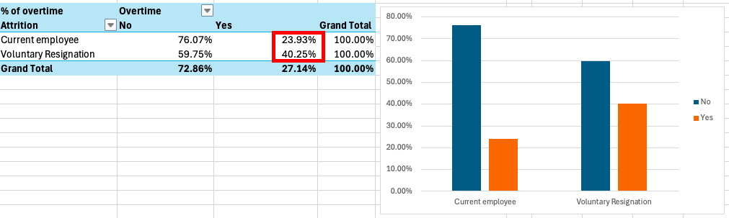
Figure 1: Overtime and Attrition Pivot Table and Bar Chart
The pivot table and the vertical bar chart from figure 1 shows that a little over 40% of the employees who resigned did overtime unlike the current employees where only over 20% of them did overtime. This shows a disparity between current and resigned employees and indicates that employees who do overtime are likely to resign. A similar study conducted by Fallucchi et al. (2020), showed that among workers who worked overtime, the percentage of attrition is over 30%, while employees who did not work overtime only have an attrition rate of 10.4%.
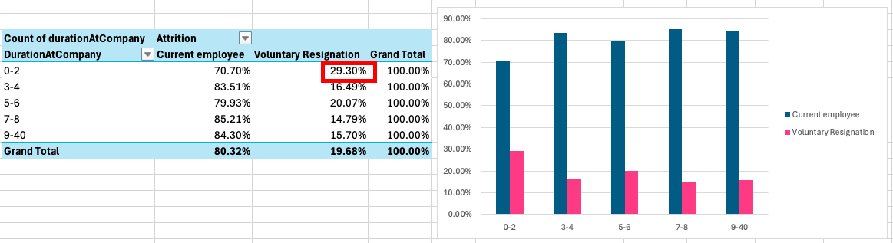
Figure 2: Bar chart representing Duration At Company and Attrition
The figure 2 above shows the relationship between attrition and years at the company. The column ‘DurationAtCompany’ was added by grouping up values in the YearsAtCompany column using the intervals ‘0-2’, ‘3-4’, ‘5-6’, 7-8’, and ‘9-40’. The data shows that there is a large gap, as resignation between employees who are quite new to the company reached almost 30% attrition rate, while employees who reached 3 or more years in the company only has around 17% attrition rate on average. This indicates that the retention plan for new employees could need more improvement and support.
Aside from descriptive analytics, we can also use diagnostic analytics to see if there is a trend or correlation between variables. This is useful in supporting decisions with data (Cote, 2021). In this case we can use it to see if there is a connection between attrition rate and employee overtime.
Chi-square test, a type of diagnostic analytics method, is best used when comparing categorical data to check for null hypothesis (Nigam, 2022). In this case, Chi-Square test can be a good indicator in checking whether there is correlation between attrition and overtime. First we create the observed value table. Then we create expected value table, then we calculate for the Chi-square using the 2 tables. The figure below shows the result of the Chi-Square Test.
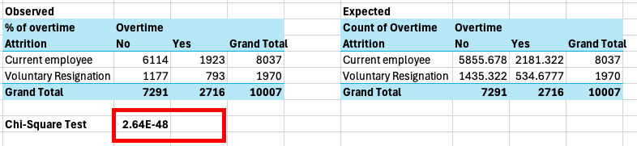
Figure 3 Overtime and Attrition Chi-Square Test
The value of Chi-Square test is shown in the figure 3 above, and since The p value(2.64E-48) is less than 0.05, we can reject the null hypothesis and conclude that there is significant relationship between overtime and attrition.
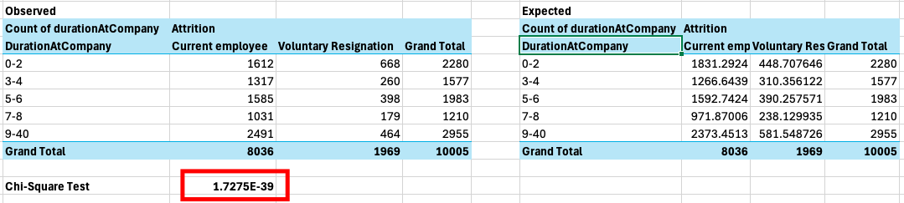
Figure 4 Chi-Square Test using Duration At Company and Attrition
Although ‘YearsAtCompany’ is not categorical per se, the column ‘DurationAtCompany’ is categorical since we grouped the values. This makes Chi-Square Test a valid method for this. The value of Chi-Square test is shown in the figure 4 above, and since The p value(1.7275E-39) is less than 0.05, we can reject the null hypothesis and conclude that there is significant relationship between duration at company and attrition.
Using predictive analytics, we can use historical data to forecast future scenarios or identify the likelihood of something happening (Edwards & Olavsrud, 2025). In this case we can use it to predict the likelihood of an employee resigning in relation to overtime. The predictive analytics method that will be used in this scenario will be the logistic aggression as it is best used in predictive analytics when the outcome is limited to two possible outcomes: yes/no, 0/1, and true/false (Kanade, 2022). The figure below shows the result of logistic regression using Rapidminer.
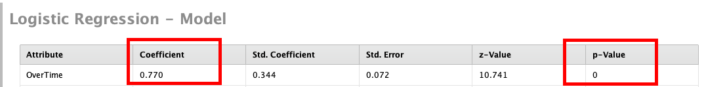
Figure 5: Logistic Regression result of Overtime and Attrition in RapidMiner
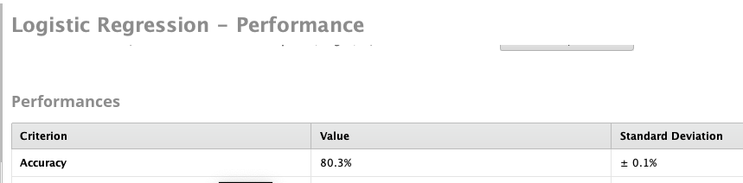
Figure 6 Overtime and Attrition Logistic Regression Accuracy
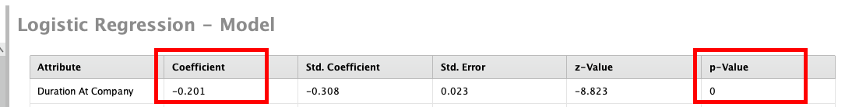
Figure 7 Logistic Regression result of Overtime and Duration At Company in RapidMiner
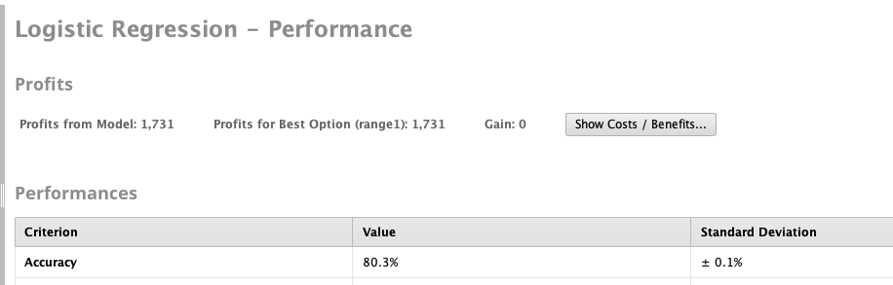
Figure 8 Attrition and Duration At Company Logistic Regression Accuracy
The figure 5 above shows the P-Value and the Coefficient results of logistic regression between Attrition and Overtime. The P-value result (0) shows that since it is less than 0.05, there is statistical significance between Attrition and Overtime. The Coefficient value signifies two things, first is that since it is greater than 0, there is a positive relationship between Attrition and Overtime. It means that as the does overtime, the risk of resigning increases. Second is that we can compute for the probability using the figure below.
For the figure 6 above, there is also statistical significance between ‘Duration At Work’ and Attrition (0 < 0.05). However for the coefficient, we cannot say that there is negative relationship between duration at work and attrition because the attrition is not in a downward trend in figure 2. Therefore calculating for the probability will not make any sense.
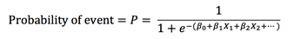
Figure 9: Probability Formula (TIBCO Software Inc., 2025)
Using the formula in figure 7, we can calculate for the probability of an employee resigning when they do overtime.
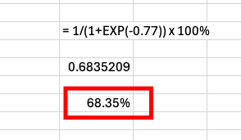
Figure 10 Probability Calculation
According to the calculation, there is almost 69% of employee resigning when they do overtime. In regards to the analyses and calculations done in this study, the actual probability of employees resigning in regards to overtime might not be as accurate as the one listed in figure 6 because the logistic regression was done using only overtime and attrition. The result could be more accurate if other factors were taken into consideration as well such as work-life balance, job satisfaction, relationship satisfaction, payrate, etc. as these factors do affect attrition of employees (Basariya & Ahmed, 2019). However, these analyses do help in making data driven decisions as one analyses might not be enough to convince stakeholders.
As a manager of a team in this company, one thing that can be done is have accurate planning to properly estimate effort needed so the overtime can be avoided or lessened. Although there is no significant relationship between overtime and work-life balance in this study, overtime has a linear relationship various stress responses such as irritability, fatigue, anxiety, depression, and somatic responses (Kikuchi et al., 2020). Focus on training and development, social support, work-life balance, compensation, development opportunities and autonomy could address employee retention of new employees of the company (Kossivi et al., 2016).

3.2 Identifying and Analysing Factors that affect Job Satisfaction in a company
(800-900 words):
The definition and significance of the problems (use appropriate intext references).
Mention the relevant variables and data types used to solve the problem (use intext references to justify the use of the variables). Tell me why did you choose these variables and how can it help solve the problem.
Mention the data analysis techniques and methods that you will use to solve the problem, provide justification for using the data analysis methods (support the justification of using the methods with appropriate intext references).
Perform the data analysis and provide appropriate results such as graphs, tables, screenshots related to the analysis.
Interpret the analysis results and tell me what the results mean for the organisation/manager.
Provide future recommendations for solving the problem and address the strengths and limitations of the analysis methods (back the recommendations and strengths/limitations with intext references).

3.3 Identifying and Analysing Factors that affect Work Life Balance in a company
(800-900 words):
The definition and significance of the problems (use appropriate intext references).
Mention the relevant variables and data types used to solve the problem (use intext references to justify the use of the variables). Tell me why did you choose these variables and how can it help solve the problem.
Mention the data analysis techniques and methods that you will use to solve the problem, provide justification for using the data analysis methods (support the justification of using the methods with appropriate intext references).
Perform the data analysis and provide appropriate results such as graphs, tables, screenshots related to the analysis.
Interpret the analysis results and tell me what the results mean for the organisation/manager.
Provide future recommendations for solving the problem and address the strengths and limitations of the analysis methods (back the recommendations and strengths/limitations with intext references).

4. Conclusion
(150-200 words): summarize your 3 problems and analysis methods. try to identify and briefly talk about some limitations regarding your dataset in 1 or 2 sentences.

5. References

Basariya, R., & Ahmed, R. R. (2019). A Study on Attrition – Turnover Intentions of Employees. International Journal of Civil Engineering and Technology (IJCIET), 10(1), 2594–2601.
Cote, C. (2021). What Is Diagnostic Analytics? 4 Examples. HBS Online. https://online.hbs.edu/blog/post/diagnostic-analytics
Edwards, J., & Olavsrud, T. (2025). What is Predictive Analytics? Transforming Data into Future Insights. CIO. https://www.cio.com/article/228901/what-is-predictive-analytics-transforming-data-into-future-insights.html
Fallucchi, F., Coladangelo, M., Giuliano, R., & William De Luca, E. (2020). Predicting Employee Attrition Using Machine Learning Techniques. Computers, 9(4). https://doi.org/10.3390/computers9040086
Ghate, R. (2020). Capstone Project-IBM Employee Attrition Prediction [Dataset]. Kaggle. https://www.kaggle.com/datasets/rushikeshghate/capstone-projectibm-employee-attrition-prediction
Ghate, R. (2025). Capstone Project-IBM Employee Attrition Prediction [Dataset]. Kaggle. https://www.kaggle.com/datasets/rushikeshghate/capstone-projectibm-employee-attrition-prediction
Kanade, V. (2022). What Is Logistic Regression? Equation, Assumptions, Types, and Best Practices. Spiceworks. https://www.spiceworks.com/tech/artificial-intelligence/articles/what-is-logistic-regression/
Kennedy, R. (2023). Focusing on the High Cost of Employee Turnover. Randstad New Zealand. https://www.randstad.co.nz/hr-news/attracting-recruiting-talent/focusing-high-cost-employee-turnover/
Kikuchi, H., Odagiri, Y., Ohya, Y., Nakanishi, Y., Shimomitsu, T., Theorell, T., & Inoue, S. (2020). Association of overtime work hours with various stress responses in 59,021 Japanese workers: Retrospective cross-sectional study. PloS One, 15(3), e0229506. https://doi.org/10.1371/journal.pone.0229506
Kossivi, B., Xu, M., & Kalgora, B. (2016). Study on Determining Factors of Employee Retention. Open Journal of Social Sciences, 4, 261–268. https://doi.org/10.4236/jss.2016.45029
Lalwani, P. (2025). What Is HR Analytics? Definition, Importance, Key Metrics, Data Requirements, and Implementation. Spiceworks. https://www.spiceworks.com/hr/hr-analytics/articles/what-is-hr-analytics/
Marler, J. H., & and Boudreau, J. W. (2017). An evidence-based review of HR Analytics. The International Journal of Human Resource Management, 28(1), 3–26. https://doi.org/10.1080/09585192.2016.1244699
Murray, E. (2019). Why Do Bar Charts Work? Forbes. https://www.forbes.com/sites/evamurray/2019/04/04/why-do-bar-charts-work/
Nigam, V. (2022). T-Test vs. Chi-Square Test: Differences and When to Use Each. Built In. https://builtin.com/data-science/t-test-vs-chi-square
Pecherskiy, M. (2016). What Is A Dataset? A Delicious Explanation. https://medium.com/quandary-dot-io/what-is-a-dataset-a-delicious-explanation-81ca1723c227
Stevens, E. (2023). 4 Levels of Measurement: Nominal, Ordinal, Interval & Ratio. https://careerfoundry.com/en/blog/data-analytics/data-levels-of-measurement/
TIBCO Software Inc. (2025). Probability Calculation Using Logistic Regression. https://docs.tibco.com/pub/sfire-dsc/6.5.0/doc/html/TIB_sfire-dsc_user-guide/GUID-C4D05ED0-3392-4407-B62A-7D29B26DC566.html

